# Instructions for the On-Premise DG to Exchange Online migrations

**Purpose:** This document is to walk through migrating Mail enabled USG and UDG to O365 DL. This is down in 4 stages; this allows rollback if required. Dynamic Groups are not supported.

**Stage 1** – Dump limited required Mail enabled USG/UDG setting to allow creation of “place holder” Distribution lists

**Stage 2** – Create DL in O365 with properties collected. This is used to compare before and after migrations. Th DL in O365 is Hidden from the GAL and has an “Cloud” name appended to the name and properties so duplicates are not created.

**Stage 3** – has two options.

Option A: Remove the on premise Main enabled USG/UDG

Option B: Move the on premise Main enabled USG/UDG to a non-synced OU

**Stage 4** – Rename the “Cloud” DL in O365 back to original name that were created and unhide them from GAL. Note: Replication of the UDG and USG from Cloud must be completed.

Note: Error Logs are created, see Errorlogs.log

**Caveats:**

* Only **Mail Enabled Groups** are migrated.
* **Dynamic** Groups are not migrated.
* **Universal Security Groups (USG)** are migrated to O365 Distribution Lists. They are **NOT** security enabled. Security context is not migrated.
* If Mail enabled Groups are not deleted but moved to an OU that is NOT synced. Group **Membership is not synced between on premise and cloud.** Manu process is needed.
* **On-premise mailboxes will NOT see cloud only Objects until migrated to O365 mailbox.** These groups will be cloud only objects.
* **Member type of the groups have only been tested with Mailboxes, not Contact or other external recipient types.** They may require manual massage of data if they are not replicated or have an external target address.

Package contains 5 Scripts:

* Step1-DumpDLsProperties.ps1
* Step2-Create Temp Groups with New name.ps1
* Step3-alt-Move to non-synced OU.ps1
* Step3-Delete migrated groups.ps1
* Step4-Rename-unhide.ps1

The Code for the scripts were found on Web and Modified to suit Customer purposes.

Requirements:

* Exchange Organization Management
  + On premise Exchange PowerShell
* Exchange Online Tenant Admin
  + Exchange Online PowerShell
* Local AD Domain Admin
  + Windows AD PowerShell
* Excel
  + Edit CSV files.

Recommend Testing in LAB environment.

* Test USG, UDG
* Test with nested Groups
* Test with groups that have mailboxes and other recipient types.

# Stage 1: Dump the required Attributes for existing USG and UDG including members.

This first Stage script **Step1-DumpDLsProperties.ps1** is used to dump the on-premise USG and UDG properties needed to create new DLs on O365. This step allows the creation of a DLs with Cloud Prepended name of your choosing. We are going to use Cloud in all Examples.

This script will create 3 CSV files.

* Distributiongroups.csv – This is a dump of the USG/UDG ***core Subset*** of properties need for creating the “Cloud” appended DLs in O365. This include Managed By; additional attributes can be added.
* distributiongroups-and-members.csv – This contains the Attributes and Members needed to import group membership.
* distributiongroups-SMTPproxy.csv – This contains additional Proxies that will be needed for reply ability

These CSV files MUST be edited after they are created, ***before***, Stage 2, 3 and 4 can be run.

Instructions to Run Script:

Copy the Scripts to “C:\DLExport”. if you need to use an alternative path. You will need to modify the Scripts Output File Path.

1. Edit the File path in the Script. Open the script in NotePad and change the File path to the location you want the Outflies to be located. The default location is “C:\DLExport\”

#This is On premise Exchange Powershell

$FilePath = "C:\DLExport\"

1. Start Exchange on-premise PowerShell, changed to the directory the Script files are located. Then Run “.\Step1-DumpDLsProperties.ps1”

[PS] C:\DLexport>.\Step1-DumpDLsProperties.ps1

1. This should create 3 CSV Files
   1. Distributiongroups.csv
   2. distributiongroups-and-members.csv
   3. distributiongroups-SMTPproxy.Csv

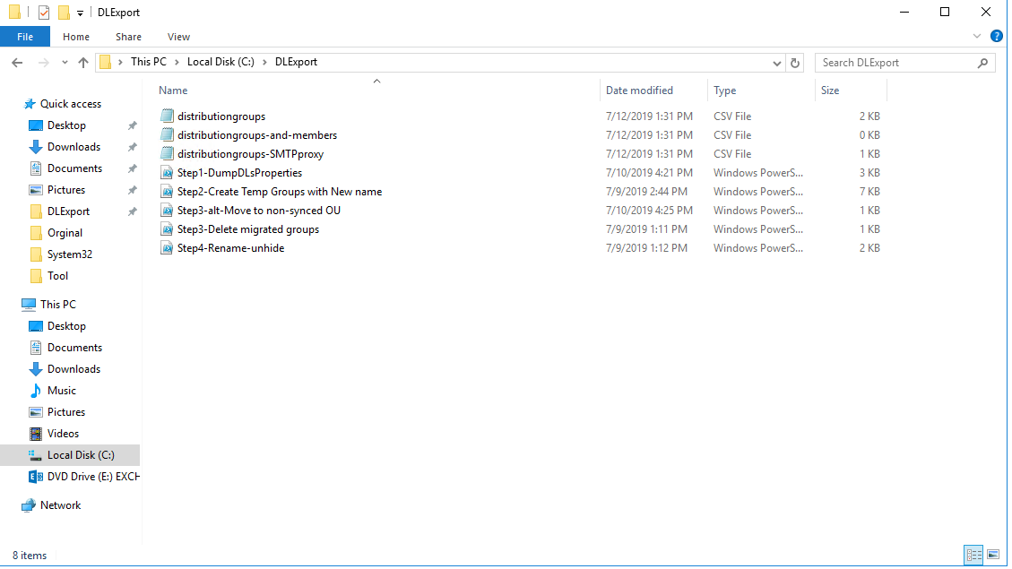

1. These files will need to be ***copied*** to the following
   1. Distributiongroups.csv 🡪 Distributiongroups_Modified.csv
   2. distributiongroups-and-members.csv 🡪 distributiongroups-and-members_Modified.csv
   3. distributiongroups-SMTPproxy.Csv 🡪 distributiongroups-SMTPproxy_Modified.Csv

Note: I recommend using Excel since we can use formulas to make modification easier. I like to create CSV files that have both ‘old’ and ‘new’ data, which allows quick roll-back if necessary. It’s best to use Excel, since we can filter and use macros. When it’s time to delete data, delete cell contents rather than delete rows – this is due to limitations when using Excel ‘filters’.  After deleting data, remember to sort the columns which will remove blank rows.

1. Open Distributiongroups_Modified.csv in Excel.
2. First let’s Filter data on the Home Tab, click Sort&Filter, then choose Filter.

[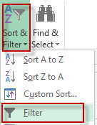](http://blogs.catapultsystems.com/wp-content/uploads/filter.jpg)

1. Create “NEW” values columns for the following. **Insert columns** after the following (**Name**, **Alias**, **DisplayName**, **PrimarySmtpAddress).** It should like below.

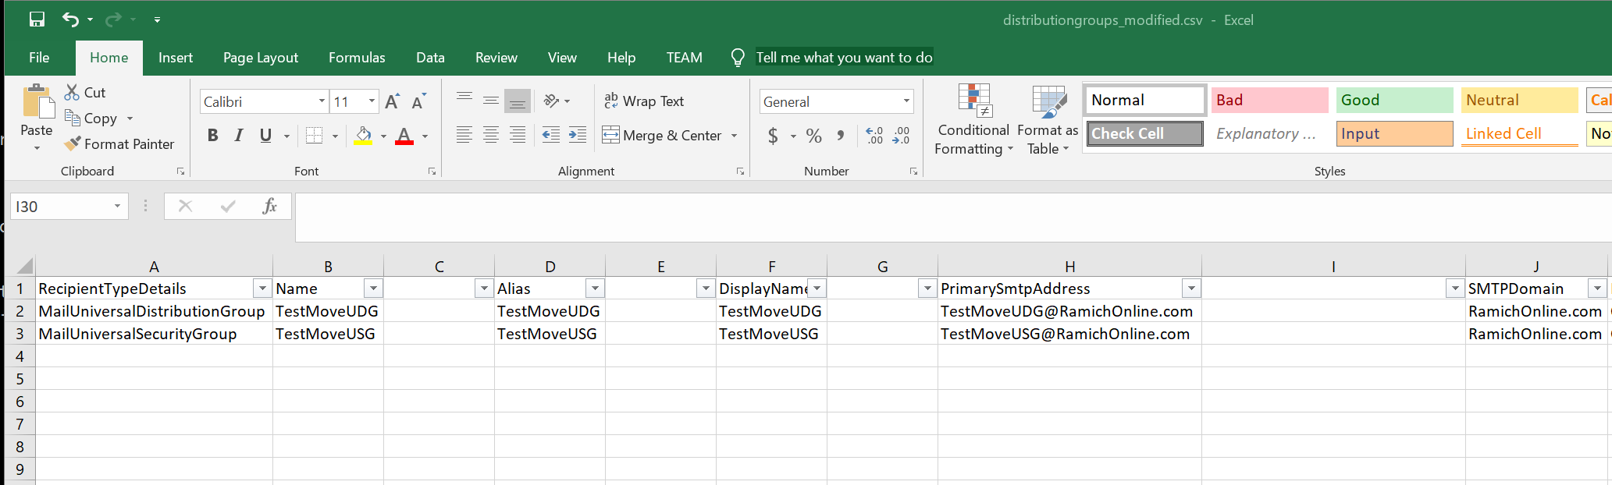

1. Add the following header for the new columns. Appends “NEW” to each one. (**Name**, NEWName, **Alias**, NEWAlias, **DisplayName**, NEWDisplayName, **PrimarySmtpAddress,** NEWPrimarySmtpAddress)

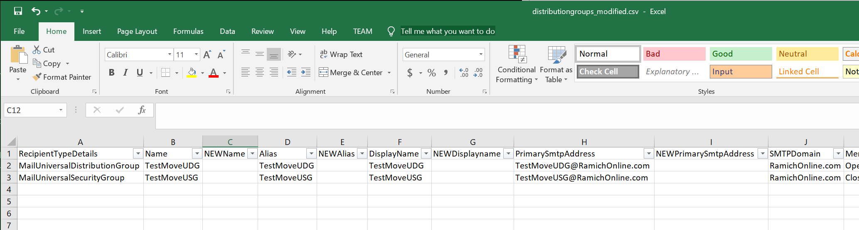

1. Add the following Formula to Cell C2 on the RED parts. “**="CLOUD"&B2**”. Chick the Check to apply the formula.

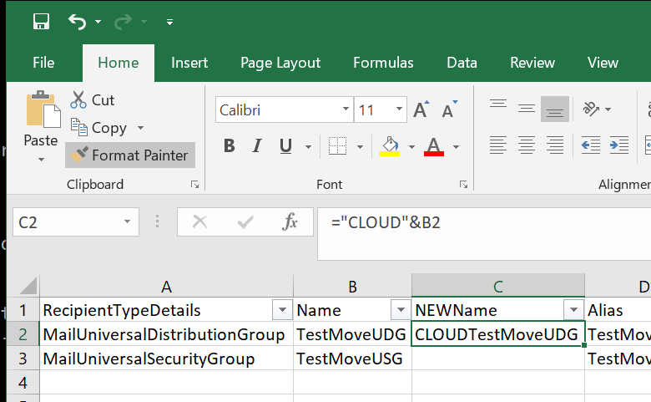

1. Then copy the formula down through data, so that all data is prefixed with “NEW”. Excel will increment the formula for you. Repeat for all the newly inserted columns.

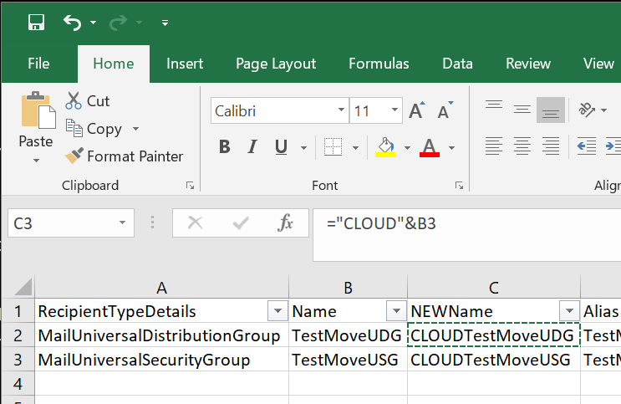

NOTE: Excel will copy the formula moving the Cell value to the correct value. See below.

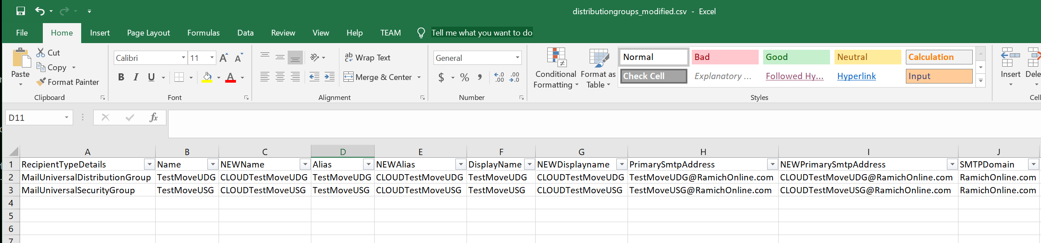

1. Next we have to clean up any attribute that has full path of the local AD. Attributes that has a full path for a user account, most notably “**ManagedBy**“, **“AcceptMessagesOnlyFrom”, “AcceptMessagesOnlyFromDLMembers”, and “AcceptMessagesOnlyFromSendersOrMembers”** columns. Leave the semicolons in place and do NOT add quotes even though DisplayName values are being used (which contain spaces).

NOTE: Instead of DisplayName, you can use SMTP Address or Alias as display names can be ambiguous if you have, let’s say, three John Smiths.

* 1. You can use “Find and Replace”, CRTL+H to complete this task.
  2. You should note, if there are blank values altogether, you might want to specify a group admin, otherwise whoever creates the new groups in PowerShell will become the owner by default. This can be important if a group requires approval to add/remove members.
  3. **e.g.:** contoso.local/User Accounts/USA/FTEmployees/Ryan Jackson; contoso.local/User Accounts/JPN/FTEmployees/Dave Rowe **—should become–>** Ryan Jackson;Dave Rowe**).**

Before Modification

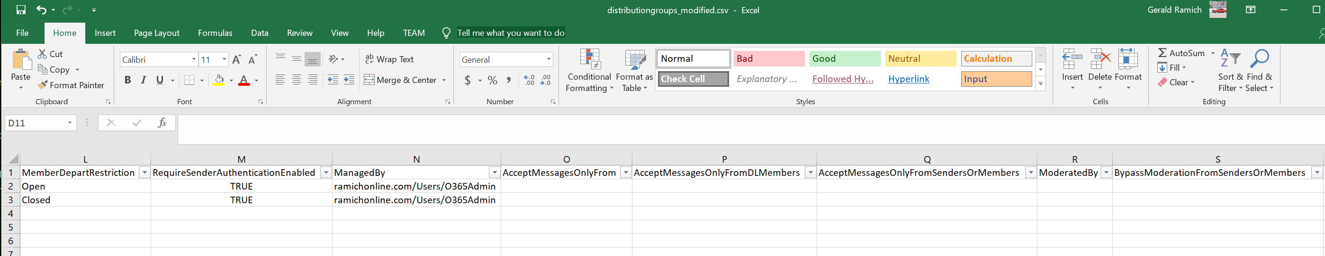

After

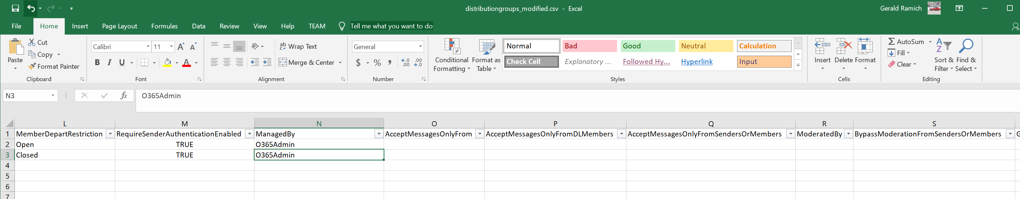

**Note:** if you want to exclude **mail-enabled security groups**, filter columns, and in *“RecipientTypeDetails” select rows with “MailUniversalSecurityGroup” and hit delete key.*

1. Save the csv file as **distributiongroups_modified.csv, Say yes to Save in current format.**
2. **Close out of Excel.**
3. Next open **distributiongroups-SMTPproxy.csv in Excel.**
4. First let’s Filter data on the Home Tab, click Sort&Filter, then choose Filter.

[](http://blogs.catapultsystems.com/wp-content/uploads/filter.jpg)

1. Let’s remove everything except alternate smtp and x500, this includes removing Primary SMTP address. We’ll need to add a few columns and use macros to help us find what we’re looking for. First let’s add a few columns.
2. Highlight Column C (TYPE), right-click and copy, then paste into Column E (skip column D this needs to eb empty for next step). Rename Column E header to “FULLADDRESS”.

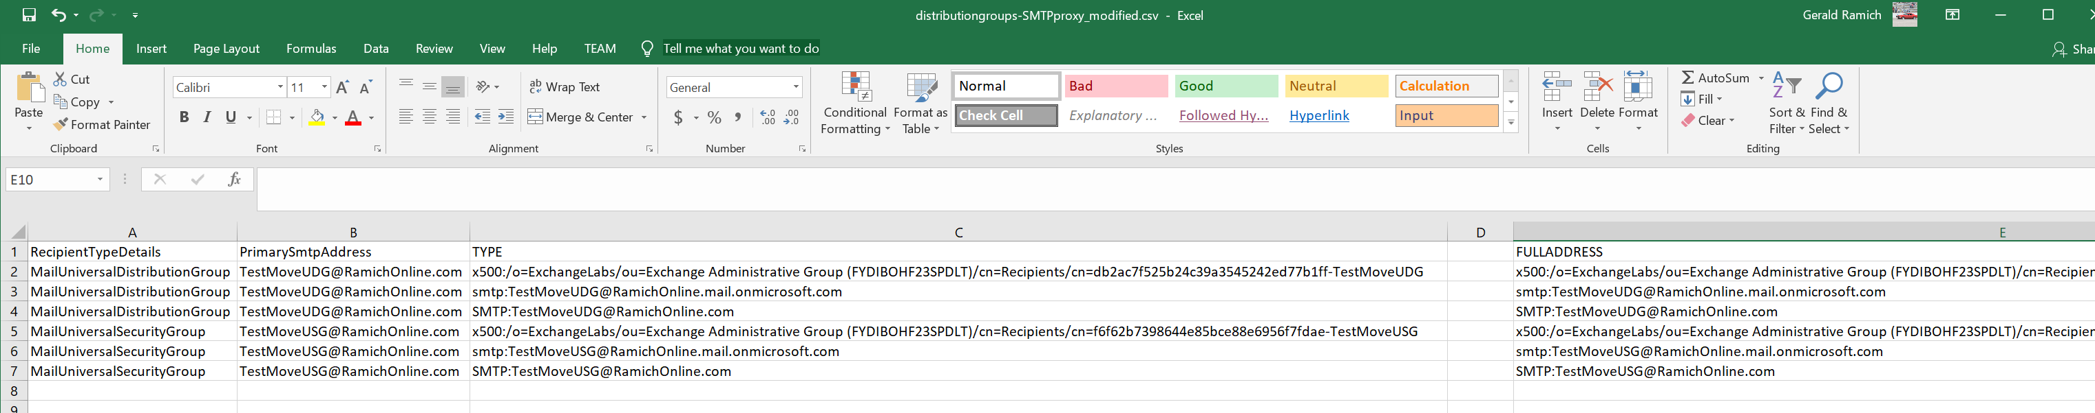

1. Go back and highlight Column C, then select ‘Data’ tab in Excel ribbon and select ‘Text to Columns’ button.

Migrate Distribution Groups from Exchange

1. Select ‘Delimited’, click Next, uncheck everything except ‘Other:’ checkbox and insert colon “:”, then click ‘Finish’. Afterwards, in Column D, give the header name “ALIAS”.

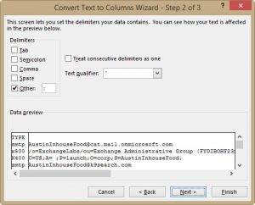

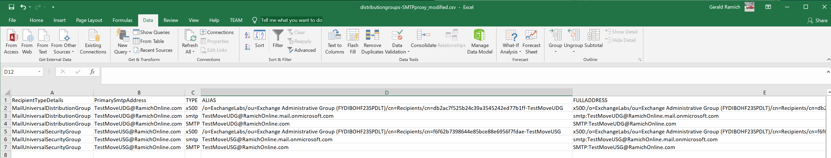

1. We’ll add one more column to help us identify uppercase SMTP. Insert a blank column after Column C and give header name “PRIMARYCHECK”. **This must be in column D**

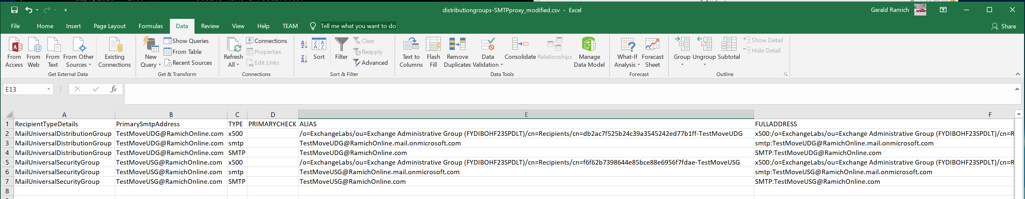

1. The following formula is case sensitive and will help us identify primary SMTP and not smtp

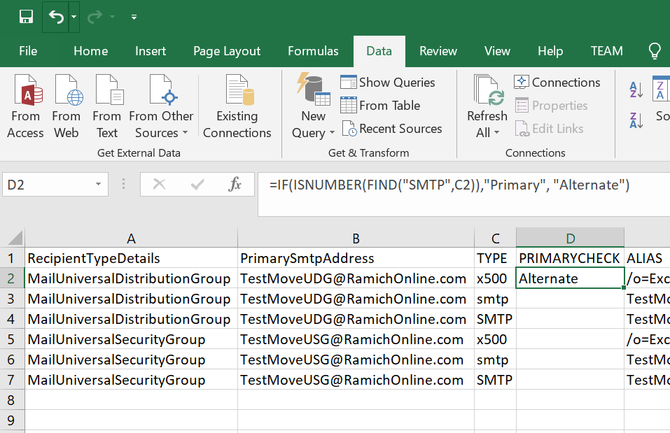

1. Copy the formula in Column D (PRIMARYCHECK) down through all data.

=IF(ISNUMBER(FIND("SMTP",C2)),"Primary", "Alternate")

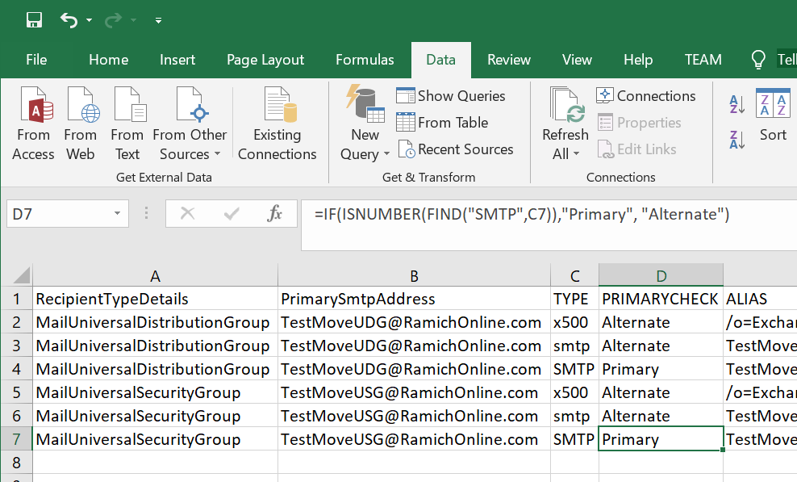

1. Now that we have all of our columns, we can now filter data and delete what we do not need. To filter data (see filter screenshot above).
2. **First** let’s delete primary SMTP. In Column D (PRIMARYCHECK) select “Primary”, then highlight the data and hit delete key. Now view all results in filter, and sort to remove blank rows.







1. **Second** let’s delete everything EXCEPT smtp and x500 (e.g. x400, EUM). While data is filtered, in Column C (TYPE), uncheck smtp, x500, and blanks – so that everything else is selected – then highlight the data and hit delete key. Now view all results in filter, and sort to remove blank rows.

**NOTE: My Example did not have any legacy addresses**

1. If there is only lowercase “smtp” and “x500” in Column C (TYPE), you are good to go. Now if you scroll to bottom you’ll see all the blank rows. You should highlight these rows from left side, right-click then select delete. Otherwise these rows will error when running scripts.
2. Save the csv file as **distributiongroups-SMTPproxy_modified.csv**
3. Exit out of Excel.
4. Open Excel. Then open **distributiongroups-and-members.csv**

*This section will fix nested-groups since they are members. In the export you can verify if any nested-groups exist. If no nested-groups exist, then just copy previous values in new columns.*

1. Create “NEW” values. Insert columns after the following (**Group, GroupSMTP**), and prefix column header with “NEW” (**Group,** NEWGroup, **GroupSMTP**, NEWGroupSMTP).

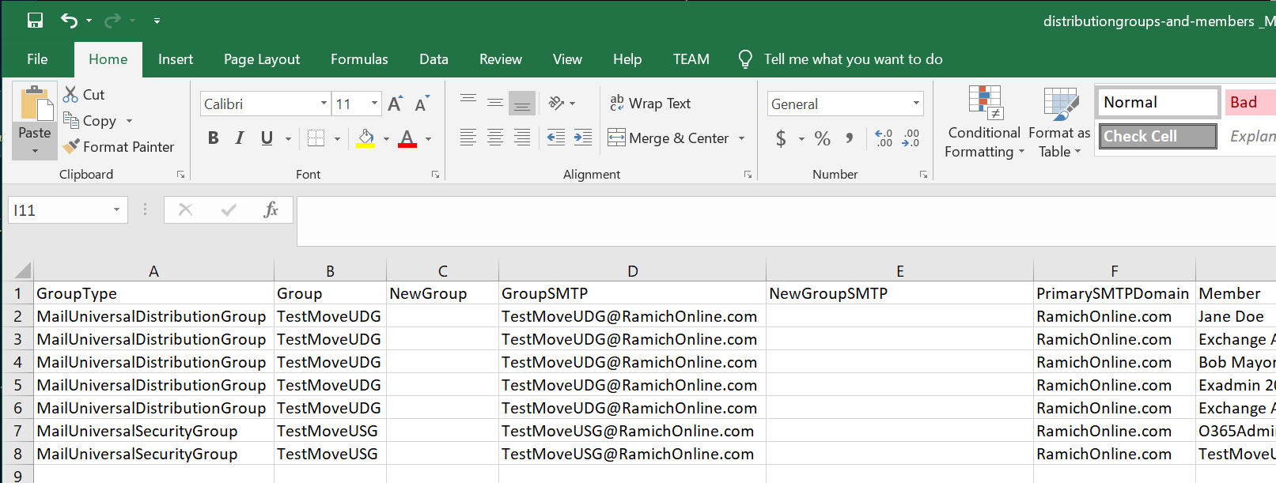

1. In Cell C2 enter the formula ="CLOUD"&B2

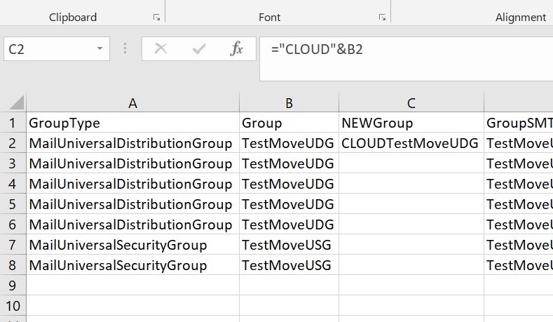

1. Copy formula down through data column, so that all data is prefixed with “NEW” in both columns NEWGroup and NEWGroupSMTP)

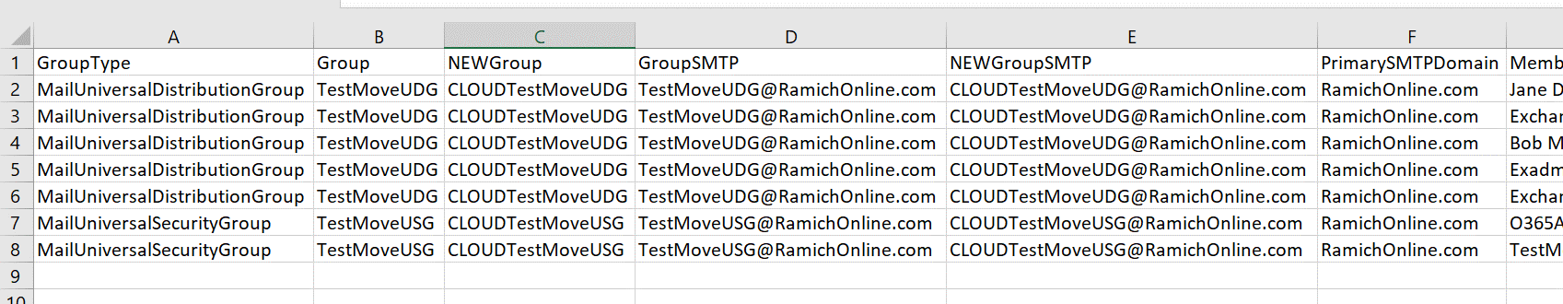

1. Next, Create “NEW” values for nested groups only, and use previous values for individual members.
2. Copy the entire column from “MemberSMTP” and **insert** as new column right next to it, then rename column header to “NEWMemberSMTP”. You should now have the following columns (**MemberSMTP,** NEWMemberSMTP).
3. Now filter data (see previous screenshot) and go to “MemberType” column and select the following values (MailUniversalDistributionGroup, DynamicDistributionGroup, MailUniversalSecurityGroup) and unselect the rest.
4. Now you should only see nested groups in “NEWMemberSMTP” column. Replace the value with the following formula (**depending on where first cell** is, modify formula to that cell, in my example screen shot it is **H8 so you need to change this**) ="CLOUD"&H8, and copy formula to rest of cells that are displayed. This ensures the nested groups are updated with “CLOUD”.

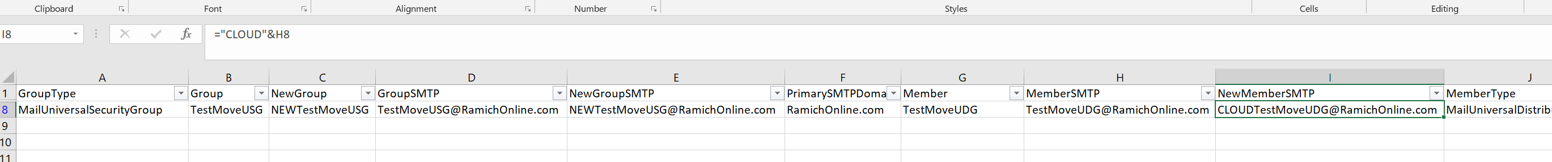

**Note:** if you excluded mail-enabled security groups from distributiongroups_modified.csv, you might consider also removing from this file too. Otherwise you’ll see errors when trying to add members to groups that don’t exist.  Filter columns, and in *“GroupType” select rows with “MailUniversalSecurityGroup” and hit delete key.*

1. To fix some ambiguous name resolution, do the following. The Member Column, needs to match the “NEWMemberSMTP” column. Copy “NEWMemberSMTP” and past into Member Column. Make sure the header column is renamed back to Member.
2. Before

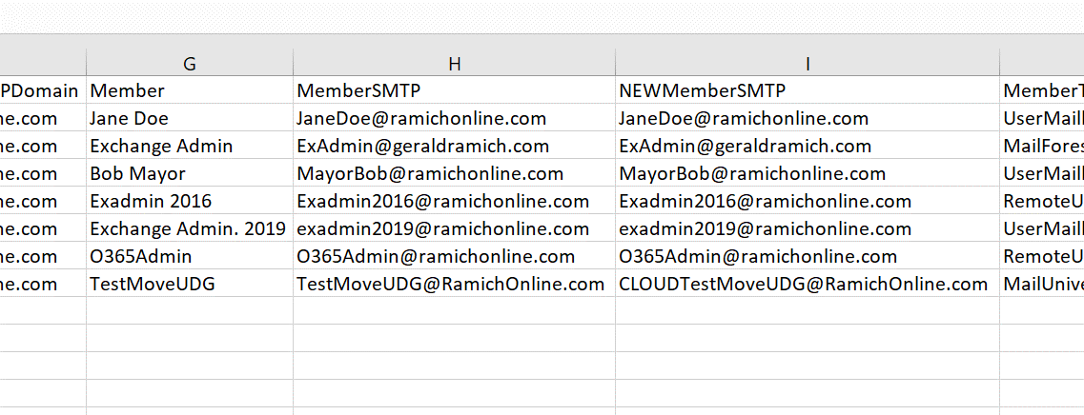

1. After, notice Column G now Matches Column I, we need to make sure to use the NEWMemberSMTP

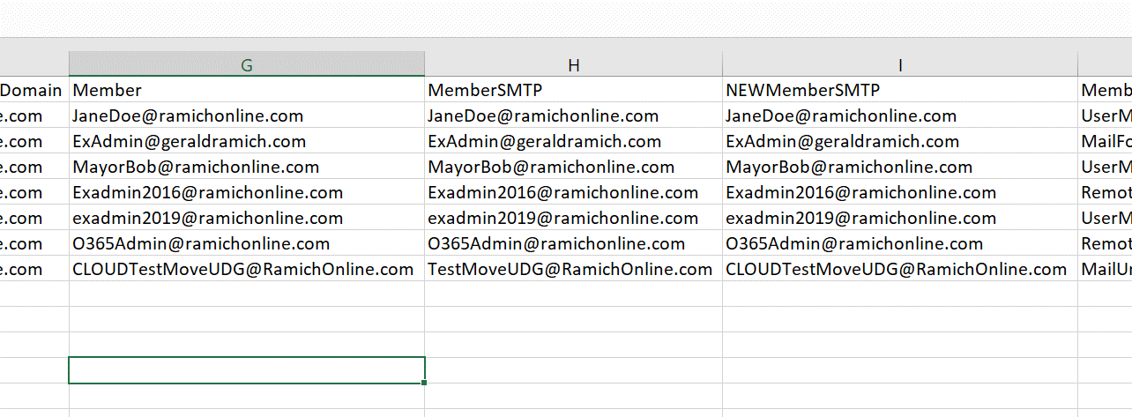

1. Save the csv file as **distributiongroups-and-members_modified.csv**
2. **Exit out of Excel.**
3. **Make sure modified files are copied to the Output Directory**

# Stage 2: Create the Cloud Temp hidden Distribution Groups

1. Open PowerShell and connect to Exchange Online. Use this or the MFA EXO Module.

$Session = New-PSSession -ConfigurationName Microsoft.Exchange -ConnectionUri https://outlook.office365.com/powershell-liveid/ -Credential $UserCredential -Authentication Basic -AllowRedirection

Import-PSSession $Session

1. Change to Script location and Run, .\Step2-Create Temp Groups with New name.ps1

# Stage 3: Either Delete the On-premise Groups OR move them to a non-synced OU.

1. Open PoweShell and change to c:\DLExport
2. Run one of the scripts based on need.
   1. If you just want to delete the groups, no modification of script it need.
      1. Run .\Step3-Delete migrated groups.ps1

or

* 1. If you need to move the couprs to an OU, modify the Script for the OU path.

# Specify target OU. This is where users will be moved.

$TargetOU = "OU=Test,DC=ramichonline,DC=com"

* + 1. Run .\Step3-alt-Move to non-synced OU.ps1

1. Wait for AD to Azure Replication to Remove Groups before going to NEXT step.

# Stage 4: Rename the existing “CLOUD” groups and un hide them from the GAL.

1. Open PoweShell and change to c:\DLExport
2. Run .\Step4-Rename-unhide.ps1